Data-Driven Packaging Optimization: Maximizing Demand, Trends, and Cost Efficiency in Packaging Industry

**Mid-term submission report for the BDM capstone Project**

Submitted by

Name: SAI MANASA NADIMPALLI

Roll number:22f1000477



IITM Online BS Degree Program,

Indian Institute of Technology, Madras, Chennai Tamil Nadu, India, 600036

Executive Summary

**Metadata**

Data Source:

The dataset has been taken directly from Techpack organization, a tile packaging company. It consists of historical data, including the tile's production, quantity, and locational information.

Data Format:

The data is structured as a tabular dataset which consists of different columns like location, year, month, tile size, and production quantity of the tiles.

Data Types:

The dataset includes both numerical and categorical data types. Numerical data includes the production quantity of the tiles. Categorical data encompasses location, year, month, and tile size.

Data Collection Period:

The dataset covers a timeframe of 5 years, allowing us to analyze trends, seasonal patterns, and demand variations over this period.

With data collected directly from Techpack, a packaging company, the dataset contains a rich blend of numerical and categorical data, covering a substantial 5-year timeframe. This metadata serves as a foundational element for the project, ensuring that our data-driven analysis is rooted in a well-documented and extensive dataset.

**Descriptive Statistics**

Total Tile Production:

The total tiles produced in the span of 5 years is calculated using Excel.

Total= 60478826

For Region KCL VN:

Tile Production for the year 2016-2017 = 4112654

Tile Production for the year 2017-2018 = 4062814

Tile Production for the year 2018-2019 = 4651230

Tile Production for the year 2019-2020 = 4386083

Tile Production for the year 2020-2021 = 3515124

The mean of tile production in KCL VN is 4145581

For Region KCL SKD:

Tile Production for the year 2016-2017 = 4646755

Tile Production for the year 2017-2018 = 5136341

Tile Production for the year 2018-2019 = 5996756

Tile Production for the year 2019-2020 = 5690828

Tile Production for the year 2020-2021 = 3317931

The mean of the tile production in KCL SKD is 4957722.5

Therefore, the mean production of tiles in KCL SKD is greater than the mean tile production in KCL VN.

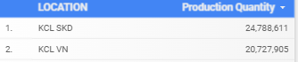

Overall the production of tiles in KCL SKD is greater than the production in KCL VN so more packaging and transportation resources should be present in KCL SKD than in KCL VN.

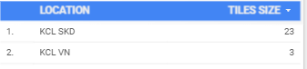

The location KCL SKD has 23 varieties of tiles produced whereas KCL VN just had 3 different types of tiles produced.

The tiles production over the past 5 years is as follows

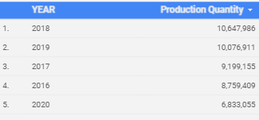

The above data tells us that the maximum demand for tiles was in the year 2018 and the minimum demand for tiles was in 2020

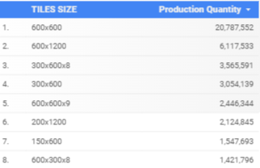

The above data tells us that the tile size along with the production quantity.

Summary Statistics for Production Quantity:

Mean: 475152.02088

Median:2883.5

Standard Deviation

Minimum: 0

Maximum: 794922

Quartiles:

25th percentile=0

50th percentile=2883.5

75th percentile=46732